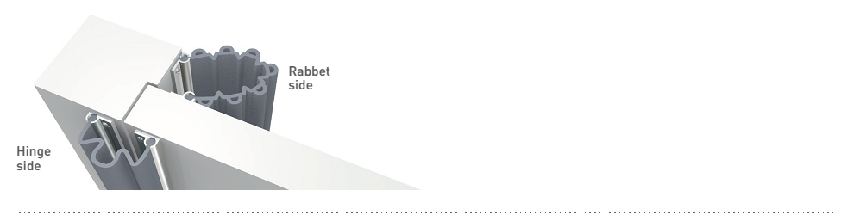

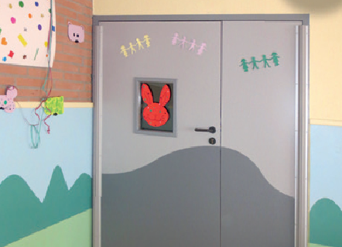

SPECIFICATION

SAFY’DOOR
DOOR FINGER PROTECTION SYSTEM
- Description: door finger protection system (Safy’Door as manufactured by SPM) to prevent fingers being trapped when opening and closing doors, comprising two solid colour, flexible elastomer sections 1.40 m in height, that slot into two pre-drilled aluminium cores. The 7-bellows section is used on the inside door jamb (rabbet side) and can cover a 150-mm gap, with the bellows providing additional extension up to 190 mm. The 3-bellows section is used on the outside door jamb (hinge side) and is designed to move with the door, compressing on opening by 20 to 80 mm.
- Environment: no heavy metals are used in its formulation, nor PBT/BPA. 100% of the product are recyclable.
- Colours: selected by architects from manufacturer’s standard range.
- Installation method: snap-fixes onto pre-drilled aluminium cores screwed to the door and frame.

